SQL ASSIGNMENT 1

1. Write a query to get a Product list (id, name, unit price) where current products cost
less than $20.

SELECT ProductID, ProductName, UnitPrice FROM Products
WHERE (((UnitPrice)<20) AND ((Discontinued)=0))
ORDER BY UnitPrice DESC;

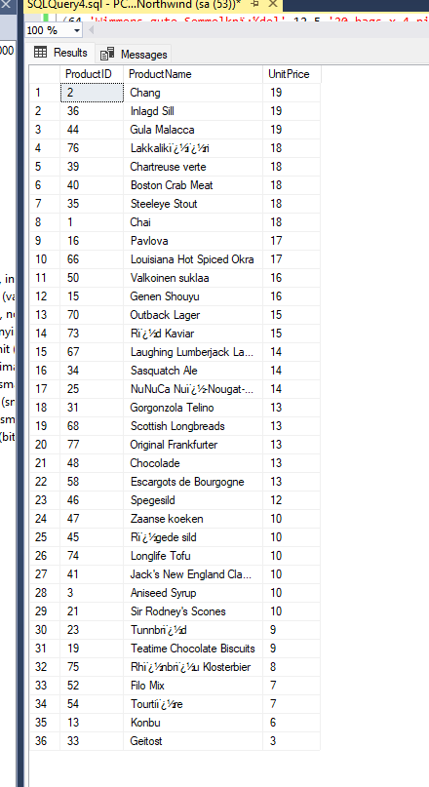

2. Write a query to get Product list (id, name, unit price) where products cost between
$15 and $25

SELECT ProductID, ProductName, UnitPrice FROM Products
WHERE UnitPrice BETWEEN 15 AND 20;

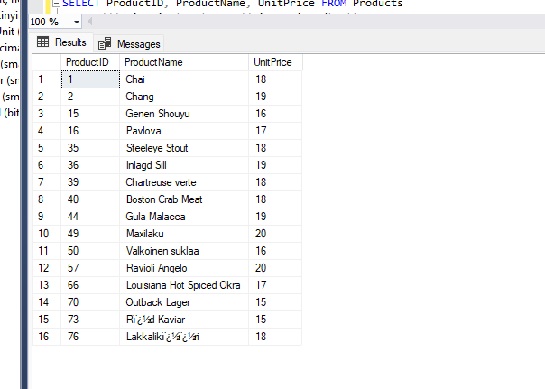

3. Write a query to get Product list (name, unit price) of above average price.

SELECT ProductName, UnitPrice FROM Products
WHERE UnitPrice > (SELECT AVG(UnitPrice) FROM Products);

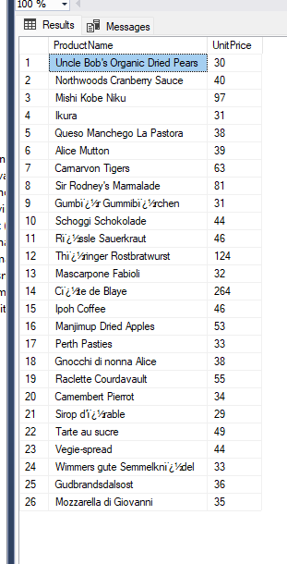

4. Write a query to get Product list (name, unit price) of ten most expensive products

SELECT TOP 10 ProductName, UnitPrice FROM Products
ORDER BY UnitPrice DESC;

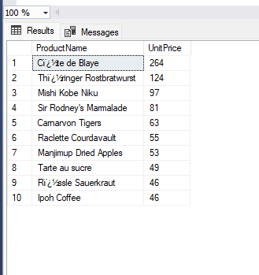

5. Write a query to count current and discontinued products

SELECT COUNT(ProductName) FROM Products
GROUP BY Discontinued;

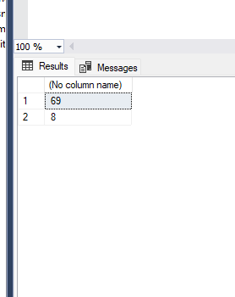

6. Write a query to get Product list (name, units on order , units in stock) of stock is less
than the quantity on order

SELECT ProductName, UnitsOnOrder, UnitsInStock FROM Products
WHERE (UnitsInStock<UnitsOnOrder);

